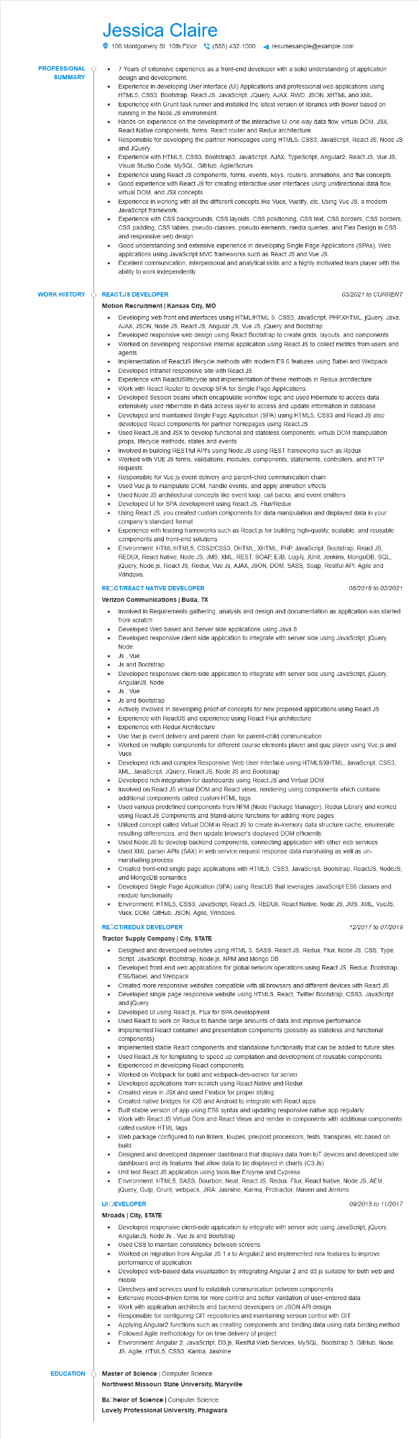
PROFESSIONAL
•
SUMMARY
WORK HISTORY
Jessica Claire
•
100 Montgomery St. 10th Floor(555) 432-1000
resumesample@example.com
7 Years of extensive experience as a front-end developer with a solid understanding of application design and development.
Experience in developing User Interface (UI) Applications and professional web applications using HTML5, CSS3, Bootstrap, React.JS, JavaScript, JQuery, AJAX, RWD, JSON, XHTML and XML. Experience with Grunt task runner and installed the latest version of libraries with Bower based on running in the Node.JS environment.
Hands-on experience on the development of the interactive UI one-way data flow, virtual DOM, JSX, React Native components, forms, React router and Redux architecture.
Responsible for developing the partner Homepages using HTML5, CSS3, JavaScript, React JS, Node JS and JQuery.
Experience with HTML5, CSS3, Bootstrap3, JavaScript, AJAX, TypeScript, Angular2, React JS, Vue JS, Visual Studio Code, MySQL, GitHub, Agile/Scrum.
Experience using React JS components, forms, events, keys, routers, animations, and flux concepts. Good experience with React JS for creating interactive user interfaces using unidirectional data flow, virtual DOM, and JSX concepts.
Experience in working with all the different concepts like Vuex, Vuetify, etc. Using Vue JS, a modern JavaScript framework.
Experience with CSS backgrounds, CSS layouts, CSS positioning, CSS text, CSS borders, CSS borders, CSS padding, CSS tables, pseudo-classes, pseudo-elements, media queries, and Flex Design in CSS and responsive web design.
Good understanding and extensive experience in developing Single Page Applications (SPAS), Web applications using JavaScript MVC frameworks such as React JS and Vue JS.
Excellent communication, interpersonal and analytical skills and a highly motivated team player with the ability to work independently.
REACT.JS DEVELOPER
Motion Recruitment | Kansas City, MO
•
•
03/2021 to CURRENT
Developing web front end interfaces using HTML/HTML 5, CSS3, JavaScript, PHP,XHTML, jQuery, Java, AJAX, JSON, Node JS, React JS, Angular JS, Vue JS, JQuery and Bootstrap
Developed responsive web design using React Bootstrap to create grids, layouts, and components Worked on developing responsive internal application using React JS to collect metrics from users and agents
Implementation of ReactJS lifecycle methods with modern ES 6 features using Babel and Webpack • Developed intranet responsive site with React JS
•
•
•
•
Experience with ReactJSlifecycle and implementation of these methods in Redux architecture Work with React Router to develop SPA for Single Page Applications
Developed Session beans which encapsulate workflow logic and used Hibernate to access data extensively used Hibernate in data access layer to access and update information in database Developed and maintained Single Page Application (SPA) using HTML5, CSS3 and React.JS also developed React components for partner homepages using React.JS
Used React.JS and JSX to develop functional and stateless components, virtual DOM manipulation props, lifecycle methods, states and events
Involved in building RESTful API's using Node.JS using REST frameworks such as Redux
Worked with VUE JS forms, validations, modules, components, statements, controllers, and HTTP requests
Responsible for Vue.js event delivery and parent-child communication chain
Used Vue.js to manipulate DOM, handle events, and apply animation effects
Used Node.JS architectural concepts like event loop, call backs, and event emitters
Developed UI for SPA development using React JS, Flux/Redux
Using React JS, you created custom components for data manipulation and displayed data in your company's standard format
Experience with leading frameworks such as React.js for building high-quality, scalable, and reusable components and front-end solutions
Environment: HTML/HTML5, CSS2/CSS3, DHTML, XHTML, PHP, JavaScript, Bootstrap, React.JS, REDUX, React Native, Node.JS, JMS, XML, REST, SOAP, EJB, Log4j, JUnit, Jenkins, MongoDB, SQL, jQuery, Node.js, React JS, Redux, Vue JS, AJAX, JSON, DOM, SASS, Soap, Restful API, Agile and Windows.
REQCT/REACT NATIVE DEVELOPER
Verizon Communications | Buda, TX
•
08/2019 to 02/2021
Involved in Requirements gathering, analysis and design and documentation as application was started from scratch
Developed Web based and Server side applications using Java 8
Developed responsive client-side application to integrate with server side using JavaScript, jQuery, Node
Js, Vue
•
Js and Bootstrap
•
Developed responsive client-side application to integrate with server side using JavaScript, jQuery, AngularJS, Node
• Js, Vue
• Js and Bootstrap
•
Actively involved in developing proof-of-concepts for new proposed applications using React JS Experience with ReactJS and experience using React Flux architecture
•
•
Experience with Redux Architecture
Use Vue.js event delivery and parent chain for parent-child communication
Worked on multiple components for different course elements player and quiz player using Vue.js and Vuex
Developed rich and complex Responsive Web User Interface using HTML5/XHTML, JavaScript, CSS3, XML, JavaScript, JQuery, React.JS, Node.JS and Bootstrap
Developed rich integration for dashboards using React.JS and Virtual DOM
Involved on React.JS virtual DOM and React views, rendering using components which contains additional components called custom HTML tags
Used various predefined components from NPM (Node Package Manager), Redux Library and worked using React.JS Components and Stand-alone functions for adding more pages
Utilized concept called Virtual DOM in React.JS to create in-memory data structure cache, enumerate resulting differences, and then update browser's displayed DOM efficiently
Used Node.JS to develop backend components, connecting application with other web services Used XML parser APIs (SAX) in web service request response data marshaling as well as un- marshalling process
Created front-end single page applications with HTML5, CSS3, JavaScript, Bootstrap, ReactJS, NodeJS, and MongoDB semantics
Developed Single Page Application (SPA) using ReactJS that leverages JavaScript ES6 classes and module functionality
•
Environment: HTML5, CSS3, JavaScript, React.JS, REDUX, React Native, Node.JS, JMS, XML, VueJS, Vuex, DOM, GitHub, JSON, Agile, Windows.
REACT/REDUX DEVELOPER
Tractor Supply Company | City, STATE
12/2017 to 07/2019
· Designed and developed websites using HTML 5, SASS, React JS, Redux, Flux, Node JS, CSS, Type Script, JavaScript, Bootstrap, Node.js, NPM and Mongo DB
•
Developed front-end web applications for global network operations using React JS, Redux, Bootstrap, ES6/Babel, and Webpack
Created more responsive websites compatible with all browsers and different devices with React JS Developed single page responsive website using HTML5, React, Twitter Bootstrap, CSS3, JavaScript and jQuery I
Developed UI using React js, Flux for SPA development
Used React to work on Redux to handle large amounts of data and improve performance Implemented React container and presentation components (possibly as stateless and functional components)
•
Implemented stable React components and standalone functionality that can be added to future sites Used React JS for templating to speed up compilation and development of reusable components Experienced in developing React components
Worked on Webpack for build and webpack-dev-server for server Developed applications from scratch using React Native and Redux
Created views in JSX and used Flexbox for proper styling
•
Created native bridges for iOS and Android to integrate with React apps
• Built stable version of app using ES6 syntax and updating responsive native app regularly
• Work with React JS Virtual Dom and React Views and render in components with additional components called custom HTML tags
Web package configured to run linters, loupes, pre/post processors, tests, transpires, etc based on
build
Designed and developed dispenser dashboard that displays data from lot devices and developed site dashboard and its features that allow data to be displayed in charts (C3.Js)
Unit test React JS application using tools like Enzyme and Cypress
Environment: HTML5, SASS, Bourbon, Neat, React JS, Redux, Flux, React Native, Node JS, AEM, jQuery, Gulp, Grunt, webpack, JIRA, Jasmine, Karma, Protractor, Maven and Jenkins.
UI OEVELOPER
Mroads | City, STATE
09/2015 to 11/2017
• Developed responsive client-side application to integrate with server side using JavaScript, jQuery, AngularJS, Node JS, Vue Js and Bootstrap
Used CSS to maintain consistency between screens
•
Worked on migration from Angular JS 1.x to Angular2 and implemented new features to improve performance of application
Developed web-based data visualization by integrating Angular 2 and d3.js suitable for both web and mobile
•
Directives and services used to establish communication between components
Extensive model-driven forms for more control and better validation of user-entered data Work with application architects and backend developers on JSON API design
Responsible for configuring GIT repositories and maintaining version control with GIT
•
Applying Angular2 functions such as creating components and binding data using data binding method Followed Agile methodology for on time delivery of project
Environment: Angular 2, JavaScript, D3.js, Restful Web Services, MySQL, Bootstrap 3, GitHub, Node JS, Agile, HTML5, CSS3, Karma, Jasmine
EDUCATION Master of Science | Computer Science
Northwest Missouri State University, Maryville
Bachelor of Science | Computer Science
Lovely Professional University, Phagwara

